Al-Shabaab
Ideology, Tactics, and the Impact of Globalism

Kjersti Soberg
March 2, 2025

INTRODUCTION
Harakat al-Shabaab al-Mujahideen, hereafter referred to as al-Shabaab, is a militant Islamic group based out of Somalia. Al-Shabaab's enduring presence in the Horn of Africa presents a complex challenge to regional and international security. While its affiliation with al-Qaeda provides an ideological framework, al-Shabaab's operational success stems from its ability to adapt and exploit local grievances, coupled with a sophisticated online recruitment strategy. This paper argues that al-Shabaab's resilience is not solely due to its ideological appeal or military capabilities, but also its adept utilization of the internet and its ability to forge strategic alliances with other extremist groups. By examining al-Shabaab's historical evolution, recruitment techniques, and regional impact, this analysis will highlight the critical need for a comprehensive counterterrorism approach to address the threats posed by al-Shabaab.

LITERATURE REVIEW
Historical Origins & Ideology
In Dr. Stig Jarle Hansen’s Al-Shabaab in Somalia: The History and Ideology of a Militant Islamist Group, Hansen provides a comprehensive history of al-Shabaab from 2005-2012. It examines the group's rise to power, its governance of parts of Somalia, and its subsequent decline while highlighting the interplay of global jihadi ideology with local Somali grievances. Hansen brings a unique perspective, as his writing is based on extensive fieldwork in Mogadishu. The book provides a valuable resource for scholars of Somalia and terrorism. James Barnett’s article, “The Evolution of East African Salafi-Jihadism,” Barnett reveals that al-Shabaab’s ideology is a blend of Salafi-Jihadism, Somali Nationalism, and Anti-Westernism. This ideology manifests in several key ways.
Firstly, al-Shabaab is rooted in Salafi-Jihadism, emphasizing a strict interpretation of Islamic law and the use of violence to establish an Islamic state. This belief system drives al-Shabaab's actions, including their attacks on government forces, civilians, and Western targets. Secondly, Somali Nationalism plays a crucial role, exploiting grievances against other countries and the perceived interference of foreign powers in Somalia. This resonates with the local population and helps them garner support. Finally, Anti-Westernism is a prominent feature, viewing the United States (U.S.) and its allies as enemies of Islam. This fuels their attacks on Western interests and personally justifies their opposition to international intervention in Somalia. Hansen echoes these sentiments in Al-Shabaab in Somalia. Ultimately, these two works allow readers to gain a deeper understanding of the group’s roots and motivations.
Relationship with Other Extremist Groups
Although al-Shabaab is an East African affiliate of al-Qaeda, it has also established international relations with other terrorist organizations like Islamic State of Iraq and ash-Sham (ISIS) and Boko Haram. ISIS's declaration of a global caliphate in 2014 created an ideological competition, challenging al-Qaeda's leadership and appealing to some within al-Shabaab with its aggressive tactics and territorial ambitions. In “Terrorism in Africa, The Rise of Islamist Extremism and Jihadism,” Alvi Hayat argued that this alignment has had a significant impact on al-Shabaab's evolution and its operational capabilities. The rise of ISIS presented Al-Shabaab with a dilemma, as ISIS actively sought to expand its influence into East Africa, potentially creating rival factions and disrupting Al-Shabaab's control. Simultaneously, Al-Shabaab had to carefully manage its existing allegiance to al-Qaeda, weighing the benefits of established support against the allure of the "new" jihadist model. The group responded by conducting internal purges, eliminating members suspected of ISIS sympathizers and consolidating power. This process ultimately strengthened Al-Shabaab's allegiance to al-Qaeda, demonstrating its commitment to maintaining its established relationships and strategic direction in the face of significant internal and external pressures.
Recruitment Techniques
Researchers have extensively studied al-Shabaab’s recruitment techniques. Conway et al., Fassrainer, and Botha and Abdile’s combined analysis sheds light on al-Shabaab’s ability to recruit vulnerable youth by exploiting social and economic grievances, utilizing religious indoctrination, and leveraging social media platforms to spread propaganda and radicalize individuals. For example, in their work "Terrorists' Use of the Internet: Assessment and Response," Conway et al. highlight how al-Shabaab effectively utilizes online platforms, such as YouTube and Twitter (X), to disseminate propaganda, recruit new members, and inspire lone-wolf attacks. Park et. al “signal that issues of propaganda and misinformation are especially acute in crises and present particular challenges to crisis communications groups.” This online presence allows the group to reach a wider audience and circumvent traditional counterterrorism measures. Furthermore, Fassrainer's research in "Tweeting Terror Live" demonstrates the group's sophisticated use of social media to spread fear and manipulate public opinion.

TRACING THE ROOTS OF AL-SHABAAB
Al-Shabaab exploded onto the international stage in 2013 during the Westgate Shopping Center attacks in Nairobi, Kenya. Though there are several claims as to the true origins of the group, it is largely believed to have been formally conceived in 2003. Its conceptual roots, however, began decades prior. Studies indicate that al-Shabaab was established as a sub-group of al-Ittihad al-Islamiya (AIAI), an Islamist militant group based out of Somalia in the 1980s. The fighters in AIAI, mainly comprised of veterans returning from Afghanistan, believed in violent jihad. They referred to their fight as “’defensive jihad,’ protecting the Muslim ummah [community], against Western intrusion.” Ultimately, AIAI’s beliefs and actions that contributed to the foundation of al-Shabaab. Salafi ideology offers a “comprehensive critique of the existing local and global social/political situation as immoral and inhuman and seeks to instill in the ummah a powerful sense of moral outrage and commitment to holy war.”
Al-Shabaab has “morphed several times, changing itself from a small network, into becoming a sub-group of the Sharia court movement,” and ultimately into the extremist group that it is today. From 2005-2006 the group grew from a several dozen core members to several hundred. However, in early 2007 power that al-Shabaab began to splinter. Several of its core members and influential leaders were killed and “remaining forcers were demoralized and defeated.” As it regrouped, funding for the group increased due to their affiliation and increasing alignment with al-Qaeda.

AL-SHABAAB'S RECRUITMENT TACTICS
In the age of globalization, social media has been used as an asset to extremists and those who seek to further their agenda. While the weaponization of these platforms is not unique to al-Shabaab, it has increasingly been used for external communication and recruitment alike. Today, social media presents a new threat that is global, seemingly impossible to contain, and an increasing problem in the world of extremism. Al-Shabaab has leveraged the internet to disseminate its ideology and strategically recruit new members. Ultimately, social media has allowed al-Shabaab to “better coordinate, fundraise, recruit, and demoralize its enemies” on a global scale. For example, although Omar Hammami was not directly recruited by al-Shabaab, he utilized the internet to support the group’s cause. Born in Alabama and self-radicalized, Hammami rose to become a military commander within the al-Shabaab and “emerged as one of its most effective spokesmen by explaining his reasons for joining a conflict with which he has no tangible connection.” Hammami was proficient in social media and posted both unofficial and official videos on YouTube along with messages promoting propaganda. The radicalization and rise of Hammami within the group as a Westerner reflected al-Shabaab’s “sophisticated and diverse communications strategy aimed at influencing Muslims living in the West.”
The organization’s calculated recruitment efforts have not been limited to capitalizing its efforts on the internet. Al-Shabaab established training camps throughout Somalia where it has indoctrinated the country’s youth with the teachings of al-Qaeda. In 2016, research showed that it targets potential recruits when they are most impressionable (Figure 1).
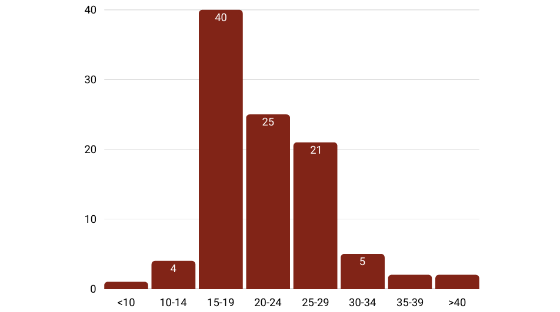
Figure 1: Age at which interviewees joined al-Shabaab.

The same study also addressed religious and economic push factors (Figure 2) being highly influential in a recruit’s decision making, which are often cited as root causes for extremism.
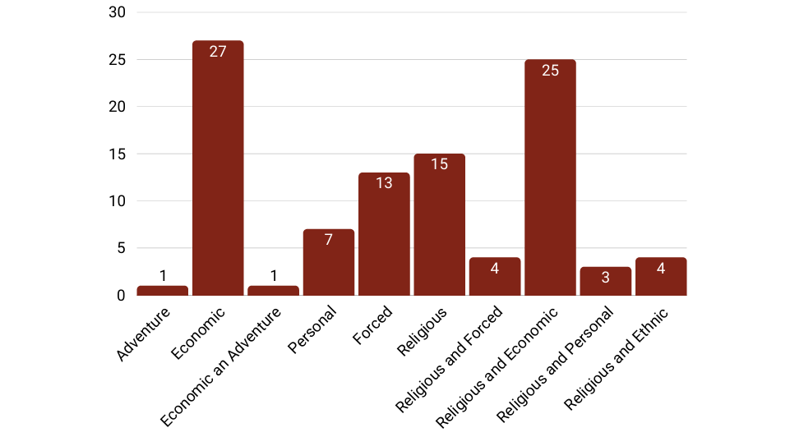
Figure 2: Interviewees' emotional inclination towards joining al-Shabaab.
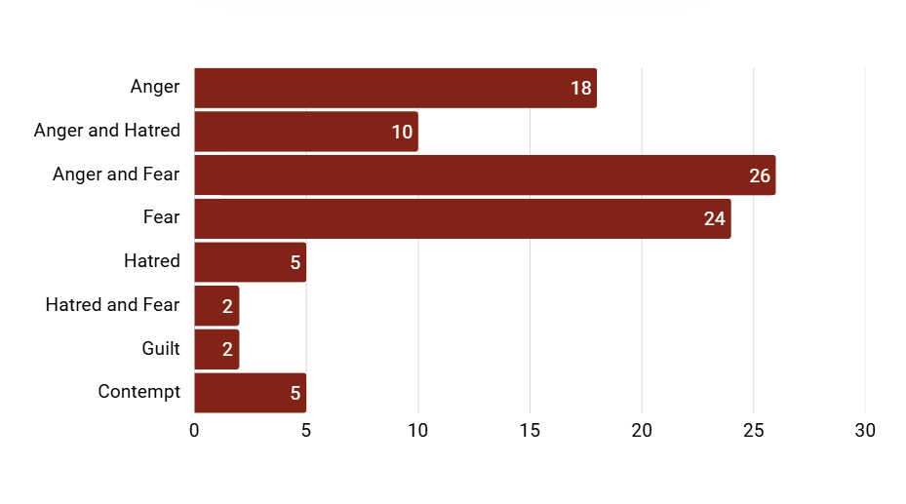
Figure 3: Interviewees’ Reasons for Joining al-Shabaab

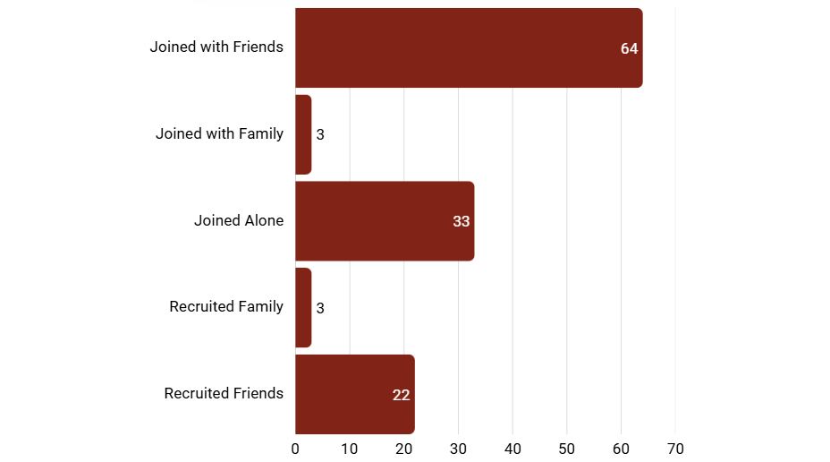
Figure 4: Influence of friends and family on interviewees.

Figures 3 and 4 also represent additional factors that played a large role in the recruitment process, tapping into other conventional recruitment vulnerabilities like adverse economic status, education, low-income jobs, or unemployment.
While the al-Shabaab’s recruitment techniques have been strategic, so too has their conscious choice to align themselves as a violent jihadist movement and “forge international links with other terrorist organizations and attract non-Somali recruits to its ranks.” These alignments have benefitted them even when the group was on the brink of collapse. In 2008 al-Shabaab publicly declared “obedience” to Osama Bin Laden and stated, “We are now negotiating to unite as one. We will take our orders from Sheik Osama bin Laden because we are his students ― once we end the holy war in Somalia, we will take it to any government that participated in the fighting against Somalia or gave assistance to those attacking us.” From this point on, attacks became more sophisticated, and al-Shabaab gained significant momentum.

AL-SHABAAB'S VIOLENT ACTIVITIES AND REGIONAL IMPACT
Al-Shabaab, now more heavily funded through its new affiliations, began using vehicle-borne improvised explosive devises (VBIEDs) as well as person-borne improvised explosive devises (PBIEDs) in their attacks. Although its attacks were targeted around Mogadishu and outlying areas, it successfully carried out attacks in Uganda, Ethiopia, Tanzania, Djibouti, and Kenya. In the fall of 2013, al-Shabaab unleashed a violent attack at the Westgate Shopping Center in Nairobi, Kenya leaving 175 wounded and sixty-seven dead. During this assault, gunmen targeted non-Muslims on a rampage that lasted four days. Al-Shabaab not only claimed responsibility on Twitter (X) but continued to use social media repeatedly throughout the ordeal. While some researchers consider this to have been an act of desperation for a faltering extremist group, others believe that it highlights al-Shabaab’s propensity for targetless violence in support of their cause.

POLICIES ON AL-SHABAAB: AMISOM, ATMIS, AND AUSSOM
Al-Shabaab’s deep roots in Salafi jihadism and propensity for violence have led to regional destabilization since its inception. Despite being pushed back from major cities by African Union (AU) forces and facing counterterrorism pressure from Western nations, al-Shabaab has proven resilient. Their control over vast swathes of rural Somalia has allowed them to continue launching deadly attacks and undermining the fragile state. This persistent threat necessitates a continued international presence in Somalia, complicating efforts to withdraw AU forces and forcing a reassessment of counterterrorism strategies.
In 2007, the United Nations (UN) Security Council addressed the threat of al-Shabaab and authorized the African Union Mission in Somalia (AMISOM) to establish a peace-keeping mission within Somalia. Counterinsurgency efforts have fluctuated in their success. Although al-Shabaab attacks have been labeled as unpredictable, they have targeted civilians for their cause. This reportedly lessened the group’s appeal and “alienated former sympathizers.” Pockets of instability within its leadership led to a slight decline in recent years, as noted in Figure 5.
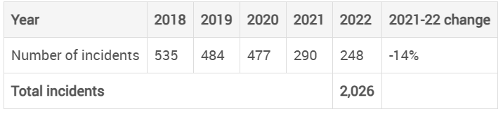
Figure 5: The decline of major terrorist incidents by Al-Shabaab from 2018-2022.
Nevertheless, al-Shabaab “remains one of the most formidable and sophisticated transnational insurgent and terrorist groups” in East Africa. AMISOM played a significant role in the attempt to stabilize Somalia by assisting Kenya in its efforts to eliminate the group. However, they encountered numerous challenges. Reports stated that “AMISOM operation [lacked] appropriate human and logistic resources as well as the strategy to stabilize the country and get rid of…al-Shabaab.” The group garnered international attention beyond the AU. In 2008, the U.S. formally recognized al-Shabaab as a foreign terrorist organization (FTO) and was categorized by defense officials as “uniquely dangerous among Africa's Salafi-jihadi groups.” Despite counterterrorism efforts by the international community, al-Shabaab continues to present itself as a serious threat.
In April of 2022, AMISOM transitioned to the African Union Transition Mission in Somalia (ATMIS). ATMIS's mandate focused on,
…degrading al-Shabaab; providing security to population centers and securing the main supply routes; developing the capacity of the Somali Security Forces (SSF)… supporting the peace and reconciliation efforts of the Federal Government of Somalia (FGS); and assisting in developing the capacity of the security and justice sector and other institutions of the FGS and Federal Member States.
This transition involved a four-phase plan with the goal of SSF assuming full responsibility by December 2024. However, the International Peace Institute (IPI) reported that ATMIS’s efforts faced significant challenges, including the continued threat posed by al-Shabaab, political instability and the limited capacity of the SSF. On December 31, 2024, ATMIS was replaced by the African Union Stabilization and Support Mission in Somalia (AUSSOM). The IPI recently stated, “considering that the new mission will likely operate much as its predecessor did, the southern Somali governments might fall to al-Shabaab even with various African troop contingents still present.” The success of the new AU mission hinges on overcoming previous challenges, including fostering political unity among Somali leaders, strengthening the SSF, and addressing the root causes of the conflict.

POLICY RECOMMENDATIONS
For seventeen years, the Federal Government of Somalia (FGS) and international community have ineffectively attempted to address the complex challenges presented by al-Shabaab. Although al-Shabaab’s efforts to seek a “total military victory against Somali authorities” have been unsuccessful, counterterrorism efforts have also failed. If al-Shabaab is to be defeated, counterinsurgency plans should focus on maintaining momentum and expanding on current efforts. This plan must include not only addressing the complexities and challenges within Somalia but bolstering key neighboring states like Kenya and Ethiopia. Moreover, success can only be achieved by countering violent extremism (CVE) through a comprehensive approach that addresses the root causes of radicalization, strengthens community resilience, and promotes alternative pathways for young people.
Recommendations for Strengthening the FGS
Strengthening Somalia’s institutions is key in combatting al-Shabaab. The FGS has made strides in state-building, but challenges remain. The potential for a security vacuum following the withdrawal of ATMIS underscores the urgent need to further strengthen the SSF. This includes enhancing their training, equipping them with modern weaponry and technology, and improving their internal structures. Addressing political divisions is crucial for Somalia's stability and the fight against al-Shabaab. Fostering dialogue and reconciliation among Somali stakeholders is essential to strengthen national unity and address underlying grievances that fuel extremism. Furthermore, providing adequate humanitarian assistance is critical. Addressing the humanitarian needs of the Somali people is necessary for long-term stability and for creating an environment where the government can effectively counter al-Shabaab and mitigate its recruitment efforts.

CONCLUSION
Al-Shabaab's enduring threat in the Horn of Africa stems from its adept exploitation of local grievances, sophisticated online recruitment, and complex alliances with other extremist groups. Despite international efforts, including successive AU missions, purely military approaches have proven insufficient. A comprehensive strategy is imperative, one that prioritizes strengthening the Somali government, fostering regional cooperation, and investing in initiatives to counter radicalization. The transition to AUSSOM must address the shortcomings of its predecessors by building the SSF’s capacity, promoting political unity, and tackling the humanitarian crisis. Ultimately, defeating al-Shabaab requires a holistic approach that connects security, development, and governance, empowering Somalis to build a stable future.

Bibliography

“Al-Shabaab joining al Qaeda, monitor group says.” CNN, February 10, 2012. www.cnn.com/2012/02/09/world/africa/somalia-shabaab-qaeda/index.html.
Alvi, Hayat. “Terrorism in Africa: The Rise of Islamist Extremism and Jihadism.” Insight Turkey 21, no. 1 (2019): 111–32. www.jstor.org/stable/26776050.
“As African Union Mission in Somalia Draws Down, Al-Shabaab Remains Threat to Country, Region, Special Representative Tells Security Council.” United Nations, October 19, 2023. https://press.un.org/en/2023/sc15457.doc.htm.
“ATMIS Transition and Post-ATMIS Security Arrangements in Somalia.” International Peace Institute: Stimson Center, October 2024. www.ipinst.org/wp-content/uploads/2024/10/IPI-E-RPT-ATMIS-Transition-final.pdf.
Barnett, James. 2020. “The Evolution of East African Salafi-Jihadism.” Current Trends in Islamist Ideology 26 (July): 20.
Botha, Anneli, and Mahdi Abdile. 2016. “Radicalisation and al-Shabaab recruitment in Somalia.” The Network for Religious and Traditional Peacemakers. ISS Paper 266, Publication 2.
Bryden, Matt. 2014. “The Strategic Challenge of Somalia’s Al Shabaab: A Strategy of Choice or Necessity?” Center for Strategic and International Studies, CSIS Africa Report Program. https://csis-website-prod.s3.amazonaws.com/s3fs-public/legacy_files/files/publication/1 40221_Bryden_ReinventionOfAlShabaab_Web.pdf.
Conway, Maura, Lee Jarvis, Orla Lehane, Stuart Macdonald, and Lella Nouri. 2017. Terrorists’ Use of the Internet: Assessment and Response. NATO Science for Peace and Security Series, E, Human and Societal Dynamics. Amsterdam, Netherlands: IOS Press.
Denoeux, G. and Lynn Carter. 2009. “Guide to the Drivers of Violent Extremism.” USAID. https://pdf.usaid.gov/pdf_docs/Pnadt978.pdf.
Elmi, Afyare A. “Engaging Al-Shabaab in Somalia: Military Failures and the Merits of Dialogue.” Middle East Council on Global Affairs, October 31, 2024. www.mecouncil.org/publication/engaging-al-shabaab-in-somalia-military-failures-and-the-merits-of-dialogue/.
Fassrainer, Victoria. 2020. “Tweeting Terror Live: Al-Shabaab’s Use of Twitter during the Westgate Attack and Implications for Counterterrorism Communications.” Military Review 100 (2): 85–95.
Gebru, Micheale K. "Ethiopia and Kenya's Experience and Vulnerability to Al-Shabaab and their Counter-Terrorism Strategies: A Comparative Analysis." African Journal of Terrorism and Insurgency Research 5, no. 1 (06, 2024): 41-41–60. https://doi.org/10.31920/2732-5008/2024/v5n1a3.
Getachew, Henok. “The Post-African Union Transition Mission in Somalia and its Regional Security Implications.” Georgetown University, July 30, 2024. https://gjia.georgetown.edu/2024/07/30/the-post-african-union-transition-mission-in-somalia-and-its-regional-security-implications/.
Hansen, Stig J. 2013. Al-Shabaab in Somalia: The History and Ideology of a Militant Islamist Group. Oxford: Oxford University Press.
Hansen, Stig J., and Mohamed Husein Gaas. 2011. "Kapitel 12 Harakat Al-Shabaab, and Somalia’s Current State of Affairs." Jahrbuch Terrorismus 5 (2011): 279-94. www.jstor.org/stable/24916969.
Holseth, Darlene M. 2012. “Al Shabaab -- Is It the New Al-Qaeda?” American Intelligence Journal 30 (1): 78–83.
Jama, Abdishakur and Filiz Katman. 2019. “Peacekeeping and Social Conflict in Somalia: The Case of Amisom-African Union Mission in Somalia.” European Researcher 10.4. www.oaji.net/articles/2020/1-1590148319.pdf.
Jones, Seth G., Andrew Liepman, and Nathan Chandler. 2016. Counterterrorism and Counterinsurgency in Somalia: Assessing the Campaign Against Al Shabaab. Santa Monica, CA: RAND Corporation. www.rand.org/pubs/research_reports/RR1539.html
Kfir, Isaac. 2017. “Al-Shabaab, Social Identity Group, Human (In)Security, and Counterterrorism.” Studies in Conflict & Terrorism 40 (9): 772–89. doi:10.1080/1057610X.2016.1236569.
Klobucista, Claire, Jonathan Masters, and Mohammed Aly Sergie. “Al-Shabaab.” Council on Foreign Relations, December 6, 2022. www.cfr.org/backgrounder/al-shabaab.
Mastors, Elena, and Rhea Siers. 2014. “Omar Al-Hammami: A Case Study in Radicalization.” Behavioral Sciences & the Law 32 (3): 377–88. doi:10.1002/bsl.2108.
Meleagrou-Hitchens, Alexander, Shiraz Maher, and James Sheehan. 2012. “Lights, Camera, Jihad. Al-Shabaab’s Western Media Strategy.” The International Centre for the Study of Radicalisation and Political Violence. www.icsr.info/wp-content/uploads/2012/11/ICSR-Report-Lights-Camera-Jihad-al-Shabaab%E2%80%99s-Western-Media-Strategy.pdf.
Menkhaus, Ken. 2014. “Al-Shabaab and Social Media: A Double-Edged Sword.” The Brown Journal of World Affairs 20 (2): 309.
Park, Jung, Hong Choi, and Sung-Min Park. "Social Media's Impact on Policy Making." SERI Quarterly 4, no. 4 (October 2011): 125-29. www.armyupress.army.mil/Journals/Military-Review/English-Edition-Archives/March-April-2020/Fassrainer-Tweet-Terror/.
Ploch, Lauren. 2010. “Countering Terrorism in East Africa: The U.S. Response.” Congressional Research Service (CRS), R41473. www.fas.org/sgp/crs/terror/R41473.pdf.
Shultz, Richard H. 2008. “Global Insurgency Strategy and the Salafi Jihad Movement.” United States Air Force: Institute for National Security Studies, INSS Occasional Paper 66. www.usafa.edu/app/uploads/OCP66-Global-Insurgency-and-Salafi-Jihad-Movement.pdf.
Singer, P. W., and Emerson T. Brooking. 2019. Like War: The Weaponization of Social Media. Eamon Dolan/Houghton Mifflin Harcourt.
Sjah, Adlini Ilma Ghaisany. 2014. “Tracing Al Shabaab’s Decision to Cooperate with Al Qaeda in Somalia (2008).” Journal of Terrorism Research 5 (1): 35–45.
Speckhard, Anne, and Ardian Shajkovci. 2019. “The Jihad in Kenya: Understanding Al-Shabaab Recruitment and Terrorist Activity inside Kenya—in Their Own Words.” African Security 12 (1): 3–61. doi:10.1080/19392206.2019.1587142.
United Nations. “Al-Shabaab.” United Nations Security Council, Accessed February 4, 2025. https://main.un.org/securitycouncil/en/sanctions/751/materials/summaries/entity/al-shabaab.
U.S. Government. “Foreign Terrorist Organizations: Al-Shabaab.” U.S. National Counterterrorism Center, Accessed February 4, 2025. www.dni.gov/nctc/ftos/al_shabaab_fto.html.
Williams, Paul D. 2018. “Subduing Al-Shabaab: The Somalia Model of Counterterrorism and Its Limits.” Washington Quarterly 41 (2): 95–111. doi:10.1080/0163660X.2018.1484227.

Stig J. Hansen, Al-Shabaab in Somalia: The History and Ideology of a Militant Islamist Group, Oxford: Oxford University Press, 2013.
James Barnett, “The Evolution of East African Salafi-Jihadism,” Current Trends in Islamist Ideology 26, July 2020, 23-25.
Anne Speckhard and Ardian Shajkovci, “The Jihad in Kenya: Understanding Al-Shabaab Recruitment and Terrorist Activity inside Kenya—in Their Own Words,” African Security 12, 2019, 3.
Hayay Alvi, “Terrorism in Africa: The Rise of Islamist Extremism and Jihadism.” Insight Turkey 21, no. 1, 2019,112.
Claire Klobucista, Jonathan Masters, and Mohammed Aly Sergie, “Al-Shabaab,” Council on Foreign Relations, 2022.
“Al-Shabaab joining al Qaeda, monitor group says,” CNN, 2012.
Conway et al. 2017.
Jung Park, Hong Choi, and Sung-Min Park, "Social Media's Impact on Policy Making," SERI Quarterly 4, no. 4, October 2011, 125.
Victoria Fassrainer, “Tweeting Terror Live: Al-Shabaab’s Use of Twitter during the Westgate Attack and Implications for Counterterrorism Communications,” Military Review 100, 2020, 86.
Isaac Kfir, “Al-Shabaab, Social Identity Group, Human (In)Security, and Counterterrorism,” Studies in Conflict & Terrorism 40 (9), 2017, 776.
Hansen, 21.
Seth G. Jones, Andrew Liepman, and Nathan Chandler, Counterterrorism and Counterinsurgency in Somalia: Assessing the Campaign Against Al Shabaab, Santa Monica, CA: RAND Corporation, 2016, 10.
Richard H. Shultz, “Global Insurgency Strategy and the Salafi Jihad Movement,” United States Air Force: Institute for National Security Studies, INSS Occasional Paper 66, 2008, 91-92.
Stig J. Hansen and Mohamed Husein Gaas, "Kapitel 12 Harakat Al-Shabaab, and Somalia’s Current State of Affairs," Jahrbuch Terrorism 5, 2011, 279.
Hansen, 13.
Hansen, 14.
Ibid.
Fassrainer, 86.
P. W. Singer and Emerson T. Brooking, Like War: The Weaponization of Social Media, Eamon Dolan/Houghton Mifflin Harcourt, 2019, 194.
Ken Menkhaus, “Al-Shabaab and Social Media: A Double-Edged Sword,” The Brown Journal of World Affairs 20 (2), 2014, 309-310.
Elena Mastors and Rhea Siers, “Omar Al-Hammami: A Case Study in Radicalization,” Behavioral Sciences & the Law 32 (3), 2014, 376.
Alexander Meleagrou-Hitchens, Shiraz Maher, and James Sheehan, “Lights, Camera, Jihad. Al-Shabaab’s Western Media Strategy.” The International Centre for the Study of Radicalisation and Political Violence, 2012, 1.
Meleagrou-Hitchens et al., 2.
Hansen, 2.
Botha and Abdile, 3.
Botha and Abdile, 5.
Botha and Abdile, 5.
Botha and Abdile, 8.
Ibid.
Sjah, 35; Speckhard and Shajkovci, 3
Lauren Ploch, “Countering Terrorism in East Africa: The U.S. Response,” Congressional Research Service (CRS), R41473, 2019, 9.
Fassrainer, 85.
Matt Bryden, “The Strategic Challenge of Somalia’s Al Shabaab: A Strategy of Choice or Necessity?” Center for Strategic and International Studies, CSIS Africa Report Program, 2014, 1.
Klobucista et al., 2022.
Bryden, 1.
Bryden, 2.
Sjah, 41.
Micheale K. Gebru, "Ethiopia and Kenya's Experience and Vulnerability to Al-Shabaab and their Counter-Terrorism Strategies: A Comparative Analysis," African Journal of Terrorism and Insurgency Research 5, no. 1, 2024, 43.
Speckhard and Shajkovci, 3.
Abdishakur Jama and Filiz Katman, “Peacekeeping and Social Conflict in Somalia: The Case of Amisom-African Union Mission in Somalia.” European Researcher 10.4, 2019, 223; Paul D. Williams, “Subduing Al-Shabaab: The Somalia Model of Counterterrorism and Its Limits,” Washington Quarterly 41 (2), 2019, 95-96.
Jama and Katman, 228.
U.S. Government, “Foreign Terrorist Organizations: Al-Shabaab,” U.S. National Counterterrorism Center, 2025.
Barnett, 21.
Barnett, 20; Speckhard and Shajkovci, 3.
“ATMIS Transition and Post-ATMIS Security Arrangements in Somalia,” International Peace Institute: Stimson Center, 2024, 1.
Colin Robinson, “As ATMIS Looks to Withdraw, the Risk of Large-Scale al-Shabaab Success in Southern Somalia is High,” International Peace Institute, 2024.
Henok Hetachew, “The Post-African Union Transition Mission in Somalia and its Regional Security Implications,” Georgetown University, 2024.
Ibid.
Hetachew 2024.
Afyare A. Elmi, “Engaging Al-Shabaab in Somalia: Military Failures and the Merits of Dialogue,” Middle East Council on Global Affairs, 2024, 1.
Jones et al., 59.
“As African Union Mission in Somalia Draws Down, Al-Shabaab Remains Threat to Country, Region, Special Representative Tells Security Council,” United Nations, 2023.

